CURRICULUM VITAE  Major General Dobran Božič  Address: Karingerjeva 24, 1000 Ljubljana, Slovenia  Telephone: +386 41 789 261  e-mail: dobran.bozic@mors.si  Nationality: Slovenian  Place of Birth: Trbovlje, Slovenia  Date of Birth: September 22nd, 1964 | 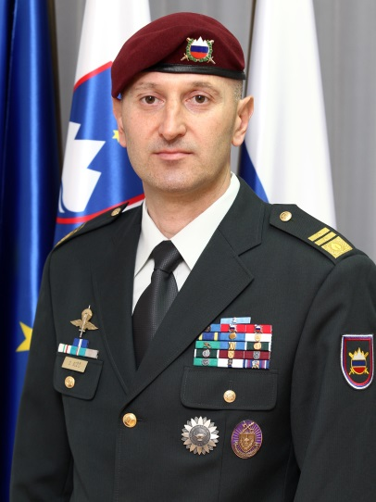

Dobran Božič has a rich career in public service, holding numerous high-level positions in the Slovenian Government. Dobran was the Chief of the General Staff of the Slovenian Armed Forces. After retiring from the military, he was appointed to the position of the Director of the Government Office for the Protection of Classified Information (National Security Authority) where he was also responsible for establishing the Cyber Security Agency in Slovenia as well as for the adoption of EU Legislation. Dobran was also the State Secretary at the Ministry of Foreign Affairs of the Republic of Slovenia, and Deputy Minister for EU Affairs, Economic Diplomacy (including OECD) and Multilateral Cooperation, which included UN, OSCE and Council of Europe. He returned to active military service in October 2022 and is holding the position as a military adviser to the Minister of Defense.

PROFFESSIONAL EXPERIENCE
GOVERNMENTAL SECTOR

2022 – Present Military Advisor to the Minister of Defense
2020 – 2022 Advisor at the Government Office for the Protection of Classified Information of the Republic of Slovenia
2018 - 2020 State Secretary at the Ministry of Foreign Affairs (Deputy Minister) of the Republic of Slovenia
2016 - 2018 Director of the Government Office for the Protection of Classified Information

PRIVATE SECTOR
1990-1993 Chief Chemist at the Aero Celje Chemical Company

MILITARY
Commander's duties:
- 2012-2014 Chief of General Staff of the Slovenian Armed Forces
- 2011-2011 Commander, Slovenian ISAF Contingent, Afghanistan
- 2009-2011 Commander, 1st Brigade, Slovenian Armed Forces
- 2007-2008 Deputy Force Commander of the Slovenian Armed Forces
- 2005-2007 Deputy Commander, 1st Brigade, Slovenian Armed Forces
- 1999-2003 Commander, 10th International Cooperation Battalion/10th Motorised Battalion

Staff and other duties:
- 2015-2016 Advisor at the MOD
- 2014-2015 Defense Representative at the Permanent Mission of the Republic of Slovenia to the United Nations
- 2011- 2012 Advisor to Deputy Chief of the General Staff of the Slovenian Armed Forces
- 2003-2005 Chief, J-7, General Staff of the Slovenian Armed Forces
- 1995-1999 Analysis and Planning Assistant, Territorial Defence Republic Staff
- 1993-1995 Deputy Chief, NBC Defence, Territorial Defence Republic Staff
- 1984-1993 Reserve member, Territorial Defence Battalion

Combat / Deployments:
- 2011 Mentor to Commander, 207th Corps, ANA, and Commander, Slovenian ISAF Contingent, Afghanistan
- 2007 Deputy Commander, Multinational Task Force West, KFOR
- 2007 Commander, Slovenian KFOR Contingent, Kosovo
- 1999 Commander, Multinational Battalion, "ESPERIA" Military Exercise
- 1991 War Veteran of the Independence War of Slovenia

EDUCATION
CIVILIAN EDUCATION:
- 2009 Master of Science, National Defense University, Washington D.C.
- 1998 Master of Science (Management and Organisations), Faculty of Economics, University of Ljubljana
- 1990 Bachelor of Science (Chemistry and Chemical Engineering), Faculty of Chemistry and Chemical Engineering, University of Ljubljana
BASIC MILITARY EDUCATION:
- 1984 Reserve Officer School
ADVANCED MILITARY EDUCATION:
- 2009 National War College, National Defense University, Washington D.C., USA
- 2006 Joint Warfighting Staff College, National Defense University, Norfolk, USA
- 2001 Command and General Staff College, Ft. Leavenworth, USA
ADDITIONAL MILITARY TRAINING
- 2004 International Unit Training Course, Land Warfare Center, Great Britain
- 2003 NATO Peace Operations Course
- 2002 Multinational Command Officers’ Course
- 1998 Legal Aspects of Peace Operations Course, Naval War College, Newport, USA
- 1997 Defence Resource Management Course, Ljubljana/Washington D.C., USA

FOREIGN LANGUAGES:
Fluent in English (spoken and written), Serbo-Croatian (spoken and written)

